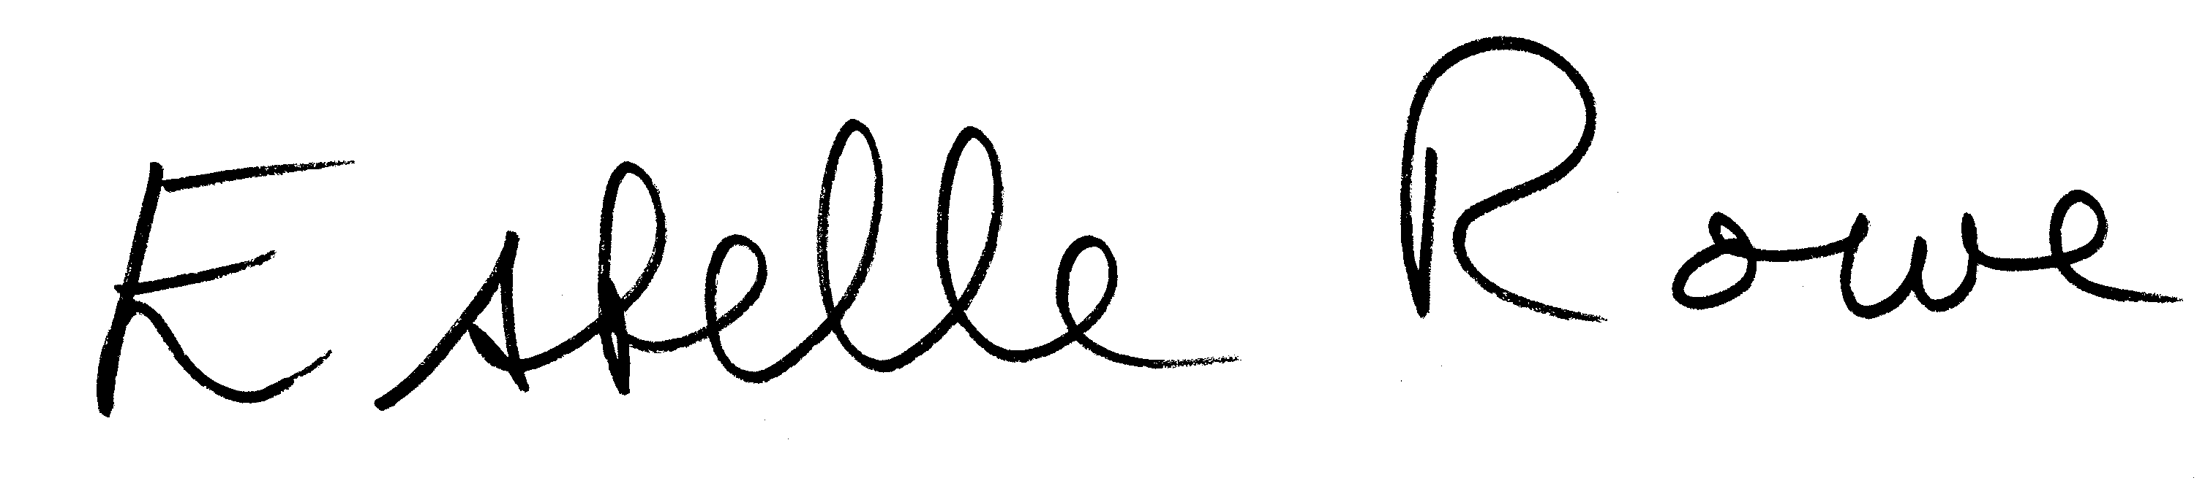

Enclosed cheque/charity voucher in the sum of: £ ...............................

Enclosed cash in the sum of: £ ................................

**If you wish to donate by Debit or Credit Card please contact us on 0121 459 3819 or donate online at**

[www.virginmoneygiving.com](http://www.virginmoneygiving.com) or [https://smartgiving.org.uk/charity/donate?=209078](https://smartgiving.org.uk/charity/donate?code=209078)

 PLEASE DONATE TO BIRMINGHAM ‘JEWISH COMMUNITY CARE

Your support will help BJCC provide essential extra care for those in our community.

We never take your support for granted, but we have earned your trust and support; Andrew Cohen House is rated **Good** by the Care Quality Commission.

If you have never given before to BJCC—please give generously **now.**

For every **£1** you donate, Gift Aid will then turn it into **£1.25**

Thank you so much for your generous and vital support.

Yours sincerely

Estelle Rowe MBE

BJCC Director

Registered Charity Number 1180758

**PLEASE USE BLOCK CAPITALS**Name:.........................................................................................................................................................

Address:......................................................................................................................................................

.......................................................................................................... Postcode: ………………………….

*Please make cheques payable to Birmingham Jewish Community Care*

Gift Aid Declaration

*Please treat all donations I have made since 6 April 2018 until I instruct you otherwise as Gift Aid Donations.*

*I am a UK taxpayer*

Under the Inland Revenue’s Gift Aid scheme, BJCC is entitled to reclaim the tax paid on gifts made by UK taxpayers. This means that, if you are a taxpayer, and pay income tax or capital gains tax at least equal to the amount we reclaim, currently 25p in the £ your gift is increased by a quarter at no extra cost to you. If you pay income tax at the higher rate, you must include all your Gift Aid donations on your Self Assessment tax return if you want to receive the additional tax relief due to you.

*Signature: .............................................................................................. Date: .......................................................*